Lecture 2
Endoplasmic reticulum
Golgi complex
Endosomes
Lysosomes and lysosomal storage diseases
Nucleus
Structure of the chromatin
Nucleolus
The nuclear and mitochondrial genomes
Overview about gene expression
Cell cycle and types of cell division
Cell aging and death
Bases of cellular pathology
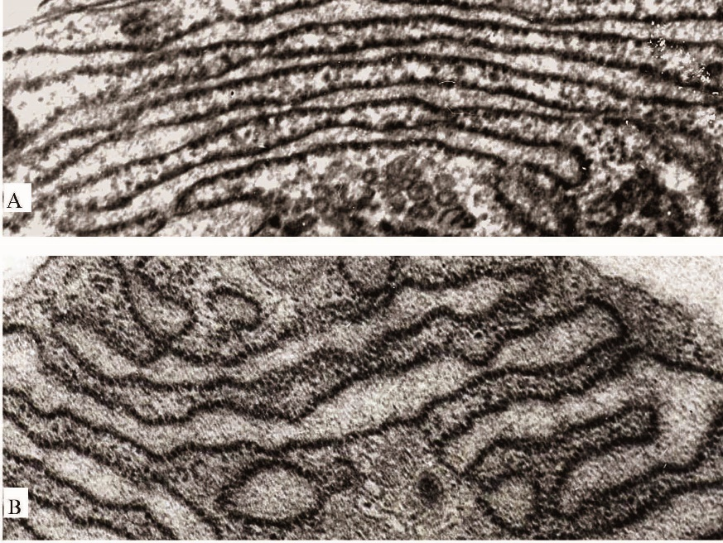
Figure 2.1.

Endoplasmic reticulum (ER) is the largest membranous system of the cell, comprising approximately half of the total membrane volume. It is a system of interconnected tubules and vesicles whose lumen is referred to as the cistern. ER has two components: smooth endoplasmic reticulum (SER) and rough endoplasmic reticulum (RER). Although only the RER participates in protein synthesis. A system of anastomosing tubules and occasional flattened membrane-bound vesicles constitute SER. The lumen of SER is assumed to be continuous with that of the rough endoplasmic reticulum. Except for cells active in synthesis of steroids, cholesterol, and triglycerides, and cells that function in detoxification of toxic materials (e.g., alcohol and barbiturates), most cells do not possess an abundance of SER. SER has become specialized in some cells (e.g., skeletal muscle cells), where it is known as sarcoplasmic reticulum (Fig. 2.1.). Here, it functions in sequestering calcium ions from the cytosol, assisting in the control of muscle contraction.
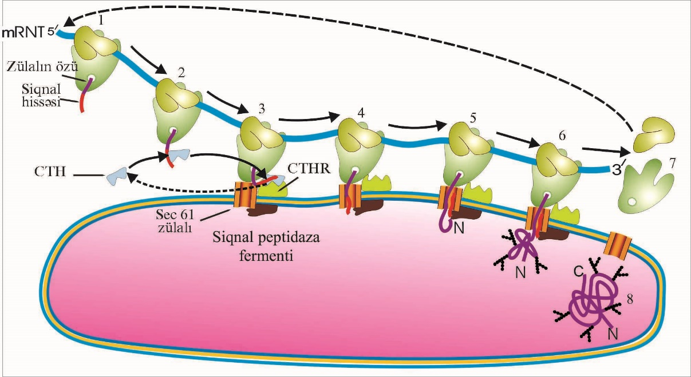
Figure 2.2.

Cells that function in the synthesis of proteins that are to be exported are richly endowed with RER. The membranes of this organelle are somewhat different from those of its smooth counterpart, because it possesses integral proteins that function in recognizing and binding ribosomes to its cytosolic surface and also maintains the flattened morphology of the RER. For the purposes of this textbook, the integral proteins of interest are (1) signal recognition particle receptor (docking protein), (2) ribosome receptor protein (ribophorin I and ribophorin II), and (3) pore protein. RER participates in the synthesis of all proteins that are to be packaged or delivered to the plasma membrane. It also performs post-translational modifications of these proteins, including sulfation, folding, and glycosylation. Additionally, lipids and integral proteins of all membranes of the cell are manufactured by the RER. The cisterna of RER is continuous with the perinuclear cistern, the space between the inner and outer nuclear membranes.
Proteins that need to be packaged either for delivery to the outside of the cell or merely isolated from the cytosol must be identified and be delivered cotranslationally (during the process of synthesis) into the RER cistern. The mode of identification resides in a small segment of the mRNA, located immediately following the start codon, which codes for a sequence of amino acids known as the signal peptide. Employing the sequence just outlined for the synthesis of protein in the cytosol, the mRNA begins to be translated, forming the signal peptide. This peptide is recognized by a protein-RNA complex located in the cytosol, the signal recognition particle (SRP). The SRP attaches to the signal peptide and by occupying the P-site on the small subunit of the ribosome halts translation; it then directs the polysome to migrate to the RER. The SRP receptor protein (docking protein) in the RER membrane contacts the SRP, and the ribosome receptor protein contacts the large subunit of the ribosome, attaching the polysome to the cytosolic surface of the RER (Fig. 2.2.). The following events then occur almost simultaneously:
- 1 The pore proteins assemble, forming a pore through the lipid bilayer of the RER.
- 2 The signal peptide contacts the pore protein and begins to be translocated (amino terminus first) into the cistern of the RER.
- 3 The SRP is dislodged, reenters the cytosol, and frees the P-site on the small ribosomal subunit. The ribosome remains on the RER surface.
- 4 As translation resumes, the nascent protein continues to be channeled into the cistern of the RER.
- 5 An enzyme attached to the cisternal aspect of the RER membrane, known as signal peptidase, cleaves the signal peptide from the forming protein. The signal peptide becomes degraded into its amino acid components.
- 6 As detailed previously, when the stop codon is reached, protein synthesis is completed, and the small and large ribosomal subunits dissociate and reenter the cytosol to join the pool of ribosomal subunits.
- 7 The newly formed proteins are folded, glycosylated, and undergo additional post-translational modifications within the RER cisternae.
- 8 The modified proteins leave the cistern via small transport vesicles (without a clathrin coat) at regions of the RER devoid of ribosomes.

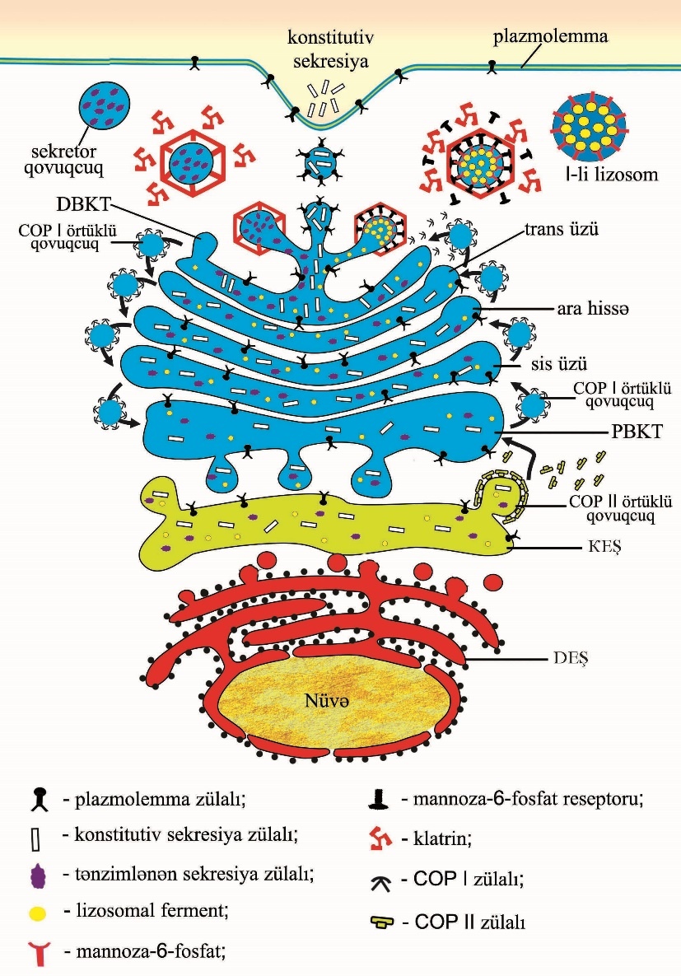
Figure 2.3.

The Golgi apparatus functions in the synthesis of carbohydrates and in the modification and sorting of proteins manufactured on the RER. Proteins manufactured and packaged in the RER follow a default pathway to the Golgi apparatus for post-translational modification and packaging. Proteins destined to remain in the RER or to go to a compartment other than the Golgi apparatus possess a signal that will divert them from the default pathway. The Golgi apparatus is composed of one or more series of flattened, slightly curved membrane-bounded cisternae, the Golgi stack, which resemble a stack of pita breads that do not quite contact each other. The periphery of each cisterna is dilated and is rimmed with vesicles that are in the process of either fusing with or budding off that particular compartment. Each Golgi stack has three levels of cisternae:
- The cis-face (or cis Golgi network)
- The medial face (intermediate face)
- The trans-face
The cis-face is closest to the RER. It is convex in shape and is considered to be the entry face, because newly formed proteins from the RER enter the cis-face before they are permitted to enter the other cisternae of the Golgi apparatus. The trans-face is concave in shape and is considered to be the exit face, because the modified protein is ready to be packaged and to be sent to its destination from here. There are two additional compartments of interest, one associated with the cis-face and the other with the trans-face. Located between the RER and the cis-face of the Golgi apparatus is an intermediate compartment of vesicles, or endoplasmic reticulum/Golgi intermediate compartment (ERGIC) and the trans Golgi network (TGN), located at the distal side of the Golgi apparatus. The ERGIC, also known as the tubulovesicular complexes, is a collection of vesicles and tubules formed from the fusion of transfer vesicles derived from the final cisterna of the RER, known as transitional endoplasmic reticulum (TER). These transfer vesicles bud off the TER and contain nascent proteins synthesized on the surface and modified within the cisternae of the RER. Vesicles derived from the ERGIC make their way to and fuse with the periphery of the cis-face of the Golgi apparatus, thus delivering the protein to this compartment for further modification. The modified proteins are transferred from the cis to the medial and finally to the trans cisternae via vesicles that bud off and fuse with the rims of the particular compartment. As the proteins pass through the Golgi apparatus, they are modified within the Golgi stack. Proteins that form the cores of glycoprotein molecules become heavily glycosylated, whereas other proteins acquire or lose sugar moieties. Mannose phosphorylation occurs within the cis-face cisterna, whereas the removal of mannose from certain proteins takes place within the cis and medial compartments of the Golgi stack. N-acetylglucosamine is added to the protein within the medial cisternae. Addition of sialic acid (N-acetylneuraminic acid) and galactose, as well as phosphorylation and sulfation of amino acids, occurs in the trans-face. Vesicles associated with the RER and Golgi apparatus possess a protein coat as well as surface markers. Vesicles that transport proteins (cargo) between organelles and regions of organelles, must have a way of budding off the organelle and must be labeled as to their destination. The process of budding is facilitated by the assembly of a proteinaceous coat on the cytosolic aspect of the organelle. Three types of coat proteins (COPs), or coatamers, are known to elicit the formation of cargo-bearing vesicles: coatomer I (COP I), coatomer II (COP II), and clathrin. At the site of future vesicle formation, these proteins coalesce, attach to the membrane, draw out the vesicle, and coat its cytosolic surface. Thus, there are COP I-coated, COP II-coated, and clathrin-coated vesicles. Transport vesicles leaving the transitional ER are always COP II-coated until they reach the ERGIC, where they shed their COP II coat, which is recycled. Vesicles that arise from the ERGIC to carry recently delivered cargo to the cis-face require the assistance of COP I, as do all other vesicles that proceed through the medial to the trans-face and the trans Golgi network. Most of the vesicles that arise from the trans Golgi network, however, require the presence of clathrin for their formation. The transport mechanism has a quality control aspect, in that if RER (or transitional ER) resident proteins are packaged in vesicles and these "stowaway" molecules reach the ERGIC, they are returned to the RER in COP I-coated vesicles. This is referred to as retrograde transport, in contrast to anterograde transport of cargo, described earlier. Because these vesicles are formed at a particular site in the cell and must reach their destination, an additional set of information should be considered; namely, how the vesicles are transported to their destination. As the cargo-containing vesicles form, they possess not only a coatomer or clathrin coat but also other surface markers and receptors. Some of these receptors interact with microtubules and the motor protein complexes that are responsible for vesicle movement (Fig. 2.3.). Sorting in the Trans Golgi Network The trans Golgi network is responsible for the sorting of proteins to their respective pathways so that they reach the plasma membrane, secretory granules, or lysosomes. Cargo that leaves the TGN is enclosed in vesicles that may do one of the following :
- Insert into the cell membrane as membrane proteins and lipids
- Fuse with the cell membrane such that the protein they carry is immediately released into the extracellular space
- Congregate in the cytoplasm near the apical cell membrane as secretory granules (vesicles), and, upon a given signal, fuse with the cell membrane for eventual release of the protein outside the cell
- Fuse with late endosomes, releasing their content into that organelle, which then becomes a lysosome
The first three processes are known as exocytosis, because material leaves the cytoplasm proper. Neither immediate release into the extracellular space nor insertion into the cell membrane requires a particular regulatory process; thus, both processes are said to follow the constitutive secretory pathway (default pathway). In contrast, the pathways to lysosomes and to secretory vesicles are known as the regulated secretory pathway.
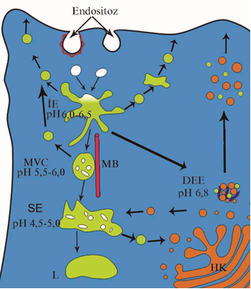
Figure 2.4.

Endosomes. Endosomes are divided into two compartments: early endosomes, near the periphery of the cell, and late endosomes, situated deeper within the cytoplasm. Shortly after their formation, pinocytotic vesicles lose their clathrin coats (which return to the pool of clathrin triskelions in the cytosol) and fuse with early endosomes, a system of vesicles and tubules located near the plasma membrane. If the entire contents of the pinocytotic vesicle require degradation, the material from the early endosome is transferred to a late endosome. This similar set of tubules and vesicles, located deeper in the cytoplasm near the Golgi apparatus, helps to prepare its contents for eventual destruction by lysosomes. Early and late endosomes, collectively, constitute the endosomal compartment. The membranes of all endosomes contain ATP-linked H⁺ pumps that acidify the interior of the endosomes by actively pumping H⁺ ions into the interior of the endosome so that the early endosome has a pH of 6.0 and the late endosome a pH of 5.5. Material entering the early endosome may be retrieved from that compartment and returned to its earlier location, as occurs with cargo receptors that need to be recycled. When the pinocytotic vesicle fuses with the early endosome, the acidic environment causes an uncoupling of the ligand from its receptor molecule. The ligand remains within the lumen of the early endosome, whereas the receptor molecules (e.g., low-density lipoprotein receptors) are returned to the plasma membrane where they originated, or to the plasma membrane of another region of the cell, a process known as transcytosis. Some authors refer to this type of early endosome as a CURL (compartment for uncoupling of receptor and ligand) or, more recently, as a recycling endosome. Within 10 to 15 minutes of entering the early endosome, the ligand either is transferred to a late endosome (as in the case of low-density lipoprotein) or is packaged to be returned to the cell membrane, where it is released (e.g., transferrin) into the extracellular space. Occasionally, both the receptor and the ligand (e.g., epidermal growth factor and its receptor) are transferred to the late endosome, and then to a lysosome, for eventual degradation. The transport between early and late endosomes has not been elucidated. Some authors suggest that early endosomes migrate along microtubule pathways into a deeper location within the cell and become late endosomes. Others postulate that early and late endosomes are two separate compartments and that specific endosomal carrier vesicles ferry material from early to late endosomes. These are believed to be large vesicles containing numerous small vesicles that have been noted as multivesicular bodies in electron micrographs. Both theories recognize the presence of a system of microtubules along which either the early endosome or the endosomal carrier vesicle negotiates its way to the late endosome (Fig. 2.4.).

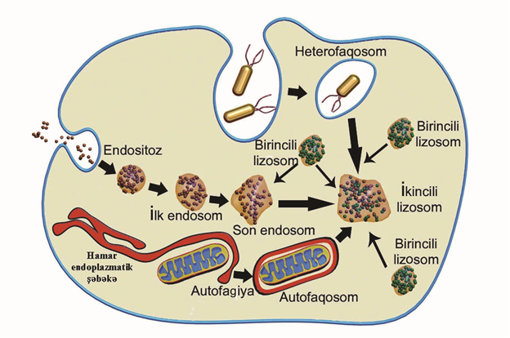
Figure 2.5.

Lysosomes. Lysosomes have an acidic pH and contain hydrolytic enzymes. The contents of late endosomes are delivered for enzymatic digestion into the lumina of specialized organelles known as lysosomes. Each lysosome is round to polymorphous in shape. Its average diameter is 0.3 to 0.8 μm, and it contains at least 40 different types of acid hydrolases, such as sulfatases, proteases, nucleases, lipases, and glycosidases, among others. Because all of these enzymes require an acid environment for optimal function, lysosomal membranes possess proton pumps that actively transport H⁺ ions into the lysosome, maintaining its lumen at a pH of 5.0. Lysosomes aid in digesting not only macromolecules, phagocytosed microorganisms, cellular debris, and cells but also excess or senescent organelles, such as mitochondria and RER. The various enzymes digest the engulfed material into small, soluble end products that are transported by carrier proteins in the lysosomal membrane from the lysosomes into the cytosol and are either reused by the cell or exported from the cell into the extracellular space. Formation of Lysosomes. Lysosomes receive their hydrolytic enzymes as well as their membranes from the trans Golgi network (TGN); however, they arrive in different vesicles. Although both types of vesicles possess a clathrin coat as they pinch off the TGN, the clathrin coat is lost shortly after formation. The uncoated vesicles then fuse with late endosomes. Vesicles ferrying lysosomal enzymes possess mannose-6-phosphate receptors, to which these enzymes are bound. In the acidic environment of the late endosome, the lysosomal enzymes dissociate from their receptors, their mannose residue becomes dephosphorylated, and the receptors are recycled by being returned to the TGN. It should be understood that the dephosphorylated lysosomal hydrolases can no longer bind to the mannose-6-phosphate receptors and therefore stay in the late endosome. When late endosomes possess both enzymatic and membrane components, some authors hypothesize that the late endosome fuses with a lysosome. However, others suggest that it matures to become a lysosome. Transport of Substances into Lysosomes. Substances destined for degradation within lysosomes reach these organelles in one of three ways: through phagosomes, pinocytotic vesicles, or autophagosomes. Phagocytosed material, contained within phagosomes, moves toward the interior of the cell. The phagosome joins either a lysosome or a late endosome. The hydrolytic enzymes digest most of the contents of the phagosome, especially the protein and carbohydrate components. Lipids, however, are more resistant to complete digestion, and they remain enclosed within the spent lysosome, now referred to as a residual body. Senescent organelles such as mitochondria and organelles no longer required by the cell, or the RER of a quiescent fibroblast, need to be degraded. The organelles in question become surrounded by elements of the endoplasmic reticulum and are enclosed in vesicles called autophagosomes (Fig. 2.5.). These structures fuse either with late endosomes or with lysosomes and share the same subsequent fate as the phagosome. Certain individuals with hereditary enzyme deficiencies are incapable of completely degrading various macromolecules into soluble by-products. A lysosomal storage disorder generally results. As the insoluble intermediaries of these substances become amassed within the lysosomes of their cells, the size of these lysosomes increases sufficiently to interfere with the abilities of these cells to perform their function. Probably the most commonly known of these conditions is Tay-Sachs disease, occurring mostly in children of Northeast European Jewish ancestry and in certain individuals of Cajun ancestry in Louisiana. These children display a deficiency in the enzyme hexosaminidase and cannot catabolize GM2 gangliosides. Although most cells in these children accumulate GM2 ganglioside in the lysosomes, it is the neurons in their central and peripheral nervous systems that are the most problematic. Lysosomes of these cells become so engorged that they interfere with neuronal function, causing the children to become vegetative within the first year or two and to die by the third year of life.

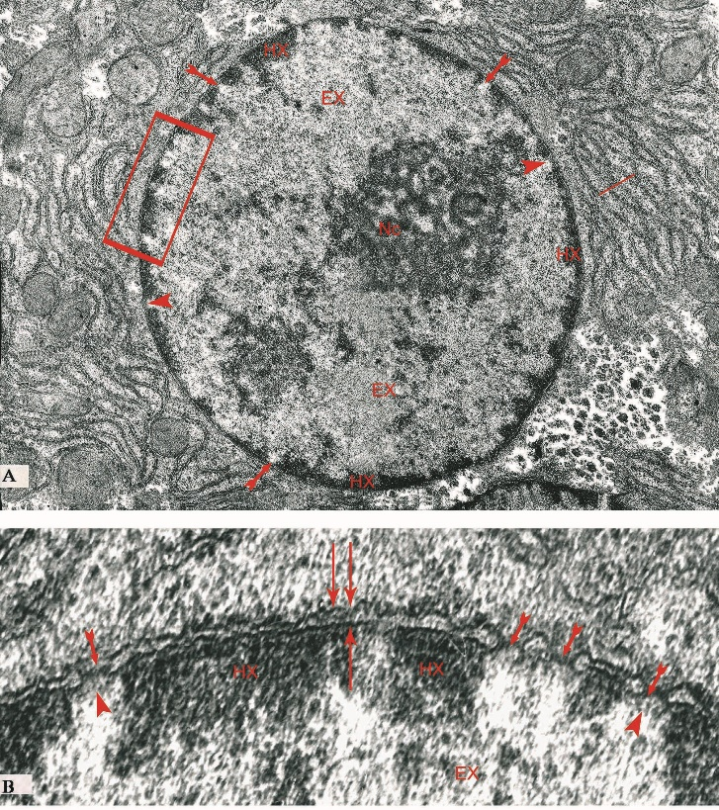
Figure 2.6.

Nucleus. The nucleus is the largest organelle of the cell. It contains nearly all of the deoxyribonucleic acid (DNA) possessed by the cell as well as the mechanisms for ribonucleic acid (RNA) synthesis, and its resident nucleolus is the location for the assembly of ribosomal subunits. The nucleus, bounded by two lipid membranes, houses three major components:
- Chromatin, the genetic material of the cell
- The nucleolus, the center for ribosomal RNA (rRNA) synthesis.
- Nucleoplasm, containing macromolecules and nuclear particles involved in the maintenance of the cell.
The nucleus is usually spherical and is centrally located in the cell; however, in some cells it may be spindle-shaped to oblong-shaped, twisted, lobulated, or even disk-shaped. Although usually each cell has a single nucleus, some cells (such as osteoclasts) possess several nuclei, whereas mature red blood cells have extruded nuclei. The size, shape, and form of the nucleus are generally constant for a particular cell type, a fact useful in clinical diagnoses of the degree of malignancy of certain cancerous cells. The nuclear envelope is composed of two parallel unit membranes that fuse with each other at certain regions to form perforations known as nuclear pores. The nucleus is surrounded by the nuclear envelope, composed of two parallel unit membranes: the inner and outer nuclear membranes, separated from each other by a 10- to 30-nm space called the perinuclear cisterna .The nuclear envelope is perforated at various intervals by nuclear pores that permit communication between the cytoplasm and the nucleus. At these pores, the inner and outer nuclear membranes are continuous with one another. The nuclear envelope helps to control movement of macromolecules between the nucleus and the cytoplasm and assists in organizing the chromatin. The inner nuclear membrane is about 6-nm thick and faces the nuclear contents. It is in close contact with the nuclear lamina, an interwoven meshwork of intermediate filaments, 80- to 100-nm thick, composed of lamins A, B, and C and located at the periphery of the nucleoplasm. The nuclear lamina help in organizing and providing support to the lipid bilayer membrane and the perinuclear chromatin, as well as play a role in the assembly of vesicles to re-form the nuclear envelope subsequent to cell division. Certain integral proteins of the inner nuclear membrane act either directly or via other nuclear matrix proteins as contact sites for nuclear RNAs and chromosomes. The outer nuclear membrane is also about 6-nm thick, faces the cytoplasm, and is continuous with the rough endoplasmic reticulum (RER). It is considered by some authors as a specialized region of the RER. Its cytoplasmic surface is surrounded by a thin, loose meshwork of the intermediate filaments, termed vimentin. Its cytoplasmic surface usually possesses ribosomes actively synthesizing transmembrane proteins that are destined for the outer or inner nuclear membranes (Fig. 2.6.).

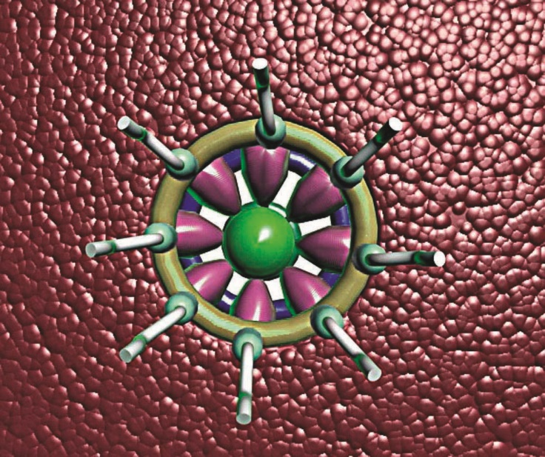
Figure 2.7.

Nuclear Pores. Nuclear pores are interruptions in the nuclear envelope, where the inner and outer nuclear membranes fuse with each other, establishing sites where communication may occur between the nucleus and the cytoplasm. At certain locations on the surface of the nuclear envelope, the outer and inner nuclear membranes are continuous with each other, creating openings known as nuclear pores, which permit communication between the nuclear compartment and the cytoplasm. The number of nuclear pores ranges from a few dozen to several thousand, correlated directly with the metabolic activity of the cell. High-resolution electron microscopy has revealed that the nuclear pore is surrounded by nonmembranous structures (glycoproteins) embedded in its rim. These structures and the pore are called the nuclear pore complex, which selectively guards passage through the pore. Evidence suggests that each of the nuclear pore complexes is in communication with the others via the nuclear lamina and certain pore-connecting fibers. The nuclear pore complex is composed of the nuclear pore and its associated glycoproteins The nuclear pore complex is about 100 to 125 nm in diameter and spans the two nuclear membranes. It is composed of three ring-like arrays of proteins stacked on top of the other, each ring displaying eight-fold symmetry and interconnected by a series of spokes arranged in a vertical fashion. In addition, the nuclear pore complex has cytoplasmic fibers, a transporter, and a nuclear basket. The cytoplasmic ring, composed of eight subunits, is located on the rim of the cytoplasmic aspect of the nuclear pore. Each subunit possesses a cytoplasmic filament, believed to be a Ran-binding protein (a family of guanosine triphosphate [GTP]-binding proteins), that extends into the cytoplasm. It has been suggested that these fibers may mediate import into the nucleus through the nuclear pore complex by moving substrates along their length toward the center of the pore. The luminal spoke ring (middle ring) is composed of a set of eight transmembrane proteins that project into the lumen of the nuclear pore as well as into the perinuclear cistern. These spoke-like proteins appear to anchor the glycoprotein components of the nuclear pore complex into the rim of the nuclear pore. The center of the middle ring is occupied by an oblong-shaped structure known as the transporter, which is coupled to the spoke-like proteins of the luminal ring. Note that the presence of the transporter (central plug) is not universally accepted because some investigators consider it to be the material being transported into or out of the nucleus. The central lumen of the middle ring is believed to be a gated channel that restricts passive diffusion between the cytoplasm and the nucleoplasm. It is associated with additional protein complexes that facilitate the regulated transport of materials across the nuclear pore complex. A nuclear ring (nucleoplasmic ring), analogous to the cytoplasmic ring, is located on the rim of the nucleoplasmic aspect of the nuclear pore and assists in the export of several types of RNA. A filamentous, flexible, basket-like structure, the nuclear basket, appears to be suspended from the nucleoplasmic ring and protruding into the nucleoplasm. The nuclear basket becomes deformed during the process of nuclear export. Attached to the distal aspect of the nuclear basket is the distal ring (Fig. 2.7.).

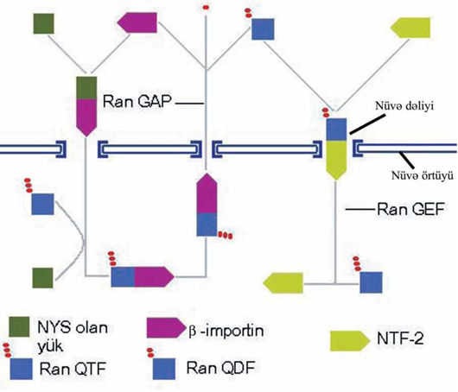
Figure 2.8.

The nuclear pore functions in bidirectional nucleocytoplasmic transport. Although the nuclear pore is relatively large, it is nearly filled with the structures constituting the nuclear pore complex. Because of the structural conformation of those subunits, several 9- to 11-nm wide channels are available for simple diffusion of ions and small molecules. However, macromolecules and particles larger than 11 nm cannot reach or leave the nuclear compartment via simple diffusion; instead, they are selectively transported via a receptor-mediated transport process. Signal sequences of molecules to be transported through the nuclear pores must be recognized by one of the many receptor sites of the nuclear pore complex. Transport across the nuclear pore complex is frequently an energy-requiring process. The bidirectional traffic between the nucleus and the cytoplasm is mediated by a group of target proteins containing nuclear localization signals (NLSs), known as importins, and nuclear export signals (NESs), known as exportins (also known as karyopherins, PTACs, transportins, and Ran-binding proteins). Exportins transport macromolecules (e.g., RNA) from the nucleus into the cytoplasm, whereas importins transport cargo (e.g., protein subunits of ribosomes) from the cytoplasm into the nucleus. Exportin and importin transport is regulated by a family of GTP-binding proteins known as Ran. These specialized proteins along with other nucleoporins located along receptor sites in the nuclear pore complex facilitate the signal-mediated import and export processes. Some protein trafficking is more like shuttling, because some proteins pass back and forth between the cytoplasm and the nucleus in a continuous fashion. Recently it has been reported that certain other transport mechanisms literally shuttle in both directions. These transport signals are called nucleocytoplasmic shuttling (NS) signals. Proteins that carry this signal interact with mRNA (Fig. 2.8.).

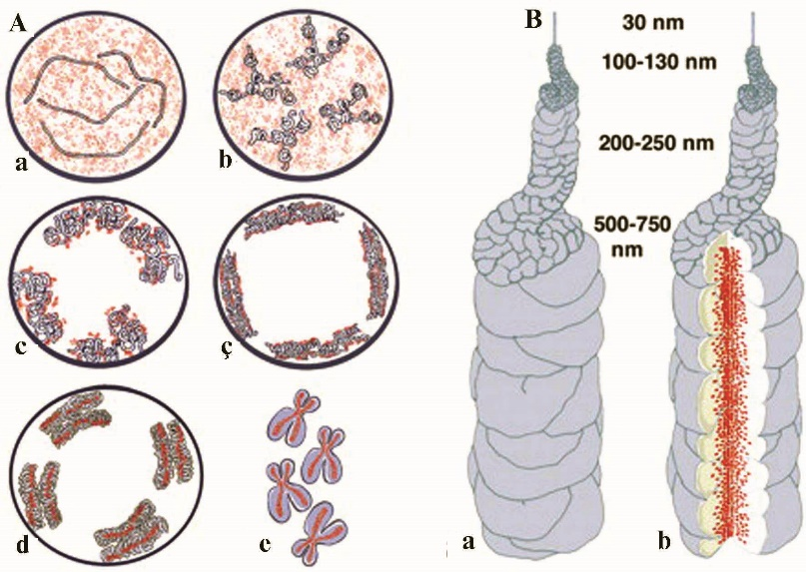
Figure 2.9.

Chromatin is a complex of DNA and proteins and represents the relaxed, uncoiled chromosomes of the interphase nucleus. DNA, the cell's genetic material, resides in the nucleus in the form of chromosomes, which are clearly visible during cell division. In the interval between cell divisions, the chromosomes are unwound in the form of chromatin. Depending on its transcriptional activity, chromatin may be condensed as heterochromatin or extended as euchromatin. Heterochromatin, a condensed inactive form of chromatin, stains deeply with Feulgen stains, which make it visible with the light microscope. It is located mostly at the periphery of the nucleus. The remainder of the chromatin, scattered throughout the nucleus and not visible with the light microscope, is euchromatin. This is the active form of chromatin in which the genetic material of the DNA molecules is being transcribed into RNA (Fig. 2.9.).
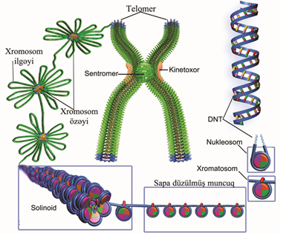
Figure 2.10.

When euchromatin is examined with electron microscopy, it is seen to be composed of a thread-like material 30-nm thick. More careful evaluation indicates that these threads may be unwound, resulting in an 11-nm wide structure resembling "beads on a string." The beads are termed nucleosomes, and the string, which is the DNA molecule, appears as a thin filament 2 nm in diameter. Each nucleosome is composed of an octomer of proteins, duplicates of each of four types of histones (H₂ A, H₂ B, H₃, and H₄). The nucleosome is also wrapped with two complete turns (∼150 nucleotide pairs) of the DNA molecule that continues as linker DNA extending to the next "bead." The spacing between each nucleosome is about 200 base pairs. This configuration of the nucleosome with its coils of DNA represents the simplest arrangement of chromatin packaging in the nucleus (Fig. 2.10.). Because only a small amount of the chromatin in the cell is in this configuration, it is thought to represent regions where the DNA is being transcribed. During the cell cycle, chromatin assembly factor 1 (CAF-1) expedites the rapid assembly of the nucleosomes of the newly synthesized DNA into chromatin so that it cannot become a template. Therefore, the nucleosome/histone assembly not only provides a structural framework for the chromatin but also imparts control mechanisms important in DNA repair, replication, and transcription.

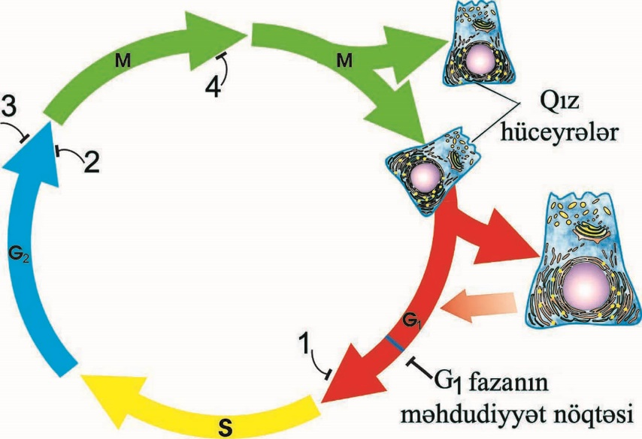
Figure 2.11.

The cell cycle is divided into two major events: interphase, a long period of time during which the cell increases its size and content and replicates its genetic material, and mitosis, a shorter period of time during which the cell divides its nucleus and cytoplasm, giving rise to two daughter cells. The cell cycle may be thought of as beginning at the conclusion of the telophase stage in mitosis, after which the cell enters interphase. Cells that become highly differentiated after the last mitotic event may cease to undergo mitosis either permanently (e.g., neurons, muscle cells) or temporarily (e.g., peripheral lymphocytes) and return to the cell cycle at a later time. Cells that have left the cell cycle are said to be in a resting stage, the G₀ (outside) phase, or the stable phase.
Interphase. Interphase is subdivided into three phases:
- G₁ (gap) phase, when the synthesis of macromolecules essential for DNA duplication begins
- S (synthetic) phase, when the DNA is duplicated
- G₂ phase, when the cell undergoes preparations for mitosis
The G₁ phase (gap 1 phase) is a period of cell growth, RNA synthesis, and other events in preparation for the next mitosis. Daughter cells formed during mitosis enter the G₁ phase. During this phase, the cells synthesize RNA, regulatory proteins essential to DNA replication, and enzymes necessary to carry out these synthetic activities. Thus, the cell volume, reduced by dividing the cell in half during mitosis, is restored to normal. Additionally, the nucleoli are reestablished during the G₁ phase. It is during this time that the centrioles begin to duplicate themselves, a process that is completed by the G₂ phase. The triggers inducing the cell to enter the cell cycle may be (1) a mechanical force (e.g., stretching of smooth muscle), (2) injury to the tissue (e.g., ischemia), and (3) cell death. All of these incidents cause the release of ligands by signaling cells in the involved tissue. Frequently these ligands are growth factors that indirectly induce the expression of proto-oncogenes, genes that are responsible for controlling the proliferative pathways of the cell. Obviously the expression of proto-oncogenes must be very strictly regulated to prevent unwanted and uncontrolled cell proliferation. Mutations in proto-oncogenes that enable the cell to escape control and divide in an unrestrained fashion are responsible for many cancers. Such mutated proto-oncogenes are known as oncogenes. Ligands designed to induce proliferation bind to cell surface receptor proteins of the target cell and activate one of the signal transduction pathways. Hence, extracellular signals that are perceived at the cell surface are transmuted into intracellular events, most of which involve the sequential activation of a cascade of cytoplasmic protein kinases. These kinases activate a series of intranuclear transcription factors that regulate the expression of proto-oncogenes, resulting in cell division. The capability of the cell to begin and advance through the cell cycle is governed by the presence and interactions of a group of related proteins known as cyclins, with specific cyclin-dependent kinases (CDKs). Thus:
- Cyclin D, synthesized during early G₁ phase, binds to CDK4 as well as to CDK6. Additionally, in the late G₁ phase cyclin E is synthesized and binds to CDK2. These three complexes, through other intermediaries, permit the cell to enter and progress through the S phase.
- Cyclin A binds to CDK2 and CDK1 and these complexes permit the cell to leave the S phase and enter the G₂ phase and induce the formation of cyclin B.
- Cyclin B binds to CDK1, and this complex allows the cell to leave the G₂ phase and enter the M phase.
Once the cyclins have performed their specific functions, they enter the ubiquitin-proteasome pathway, where they are degraded into their component molecules. The cell also employs quality control mechanisms, known as checkpoints, to safeguard against early transition between the phases. These checkpoints ensure the meticulous completion of essential events, such as adequate cell growth, correct DNA synthesis, and proper chromosome segregation, before permitting the cell to leave its current phase of the cell cycle. The cell accomplishes such delays in the progression through the cell cycle by activating inhibitory pathways and/or by suppressing activating pathways. The actual control mechanisms are considerably more involved and complicated than the steps just described. For example, it appears that the nucleolus plays a regulatory role in the cell cycle by sequestering certain proteins, thus inhibiting their function. DNA synthesis occurs during the S phase. During the S phase, the synthetic phase of the cell cycle, the genome is duplicated. All of the requisite nucleoproteins, including the histones, are imported and incorporated into the DNA molecule, forming the chromatin material. The cell now contains twice the normal complement of its DNA. The amount of DNA present in autosomal and germ cells also varies. Autosomal cells contain the diploid (2n) amount of DNA before the synthetic (S) phase of the cell cycle when the diploid (2n) amount of DNA is doubled (4n) in preparation for cell division. In contrast, germ cells produced by meiosis possess the haploid (1n) number of chromosomes and also the haploid (1n) amount of DNA. The gap 2 phase (G₂ phase) is the period between the end of DNA synthesis and the beginning of mitosis. During the G₂ phase, the RNA and proteins essential to cell division are synthesized, the energy for mitosis is stored, tubulin is synthesized for assembly into microtubules required for mitosis, DNA replication is analyzed for possible errors, and any of these errors is corrected (Fig.2.11.).

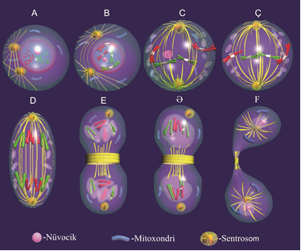
Figure 2.12.

Mitosis is divided into distinct stages:
Prophase
Prometaphase
Metaphase
Anaphase
Telophase (Fig. 2.12.)

Prophase:

- At the beginning of prophase, the chromosomes are condensing to become visible microscopically.
- As chromosome condense, the nucleolus disappears.
- The centosome also divides into two regions, each half containing a pair of centrioles and a microtubule-organizing center (MTOC), which migrate away from each other to opposite poles of the cell.
- From each MTOC, astral rays and spindle fibers develop, giving rise to the mitotic spindle apparatus.

Prometaphase:
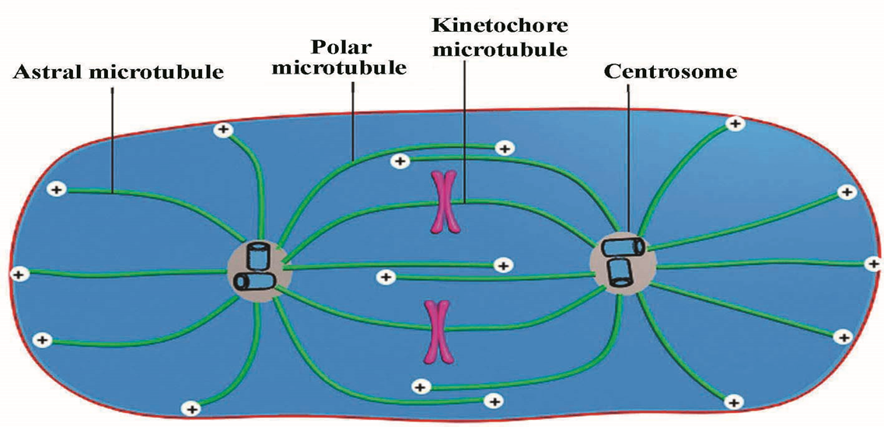
Figure 2.13.

- Nuclear lamins are phosphorylated, resulting in the breakdown and disappearance of the nuclear envelope.
- Three kinds of microtubules are discovered:
- Kinetochore (mitotic spindle) microtubules;
- Astral microtubules;
- Polar microtubules (Fig. 2.13.).

Metaphase :
- The chromosomes become maximally condensed and are lined up at the equator of the mitotic spindle (metaphase plate configuration).
- Each chromatid parallels the equator, and spindle microtubules are attached to its kinetochore, radiating to the spindle pole.

Anaphase:
- The sister chromatids are held together by the ring of proteins called cohesins.
- The activity of cohesin complex is depended on the separase and inactivated it securin.
- Under action of CDK1/cyclin B anaphase-promoting complex (APC) is activated and breaks the securin.
- It results activation of separase which breaks the cohesin complex.
- Thus, separation of chromatids is initiated.

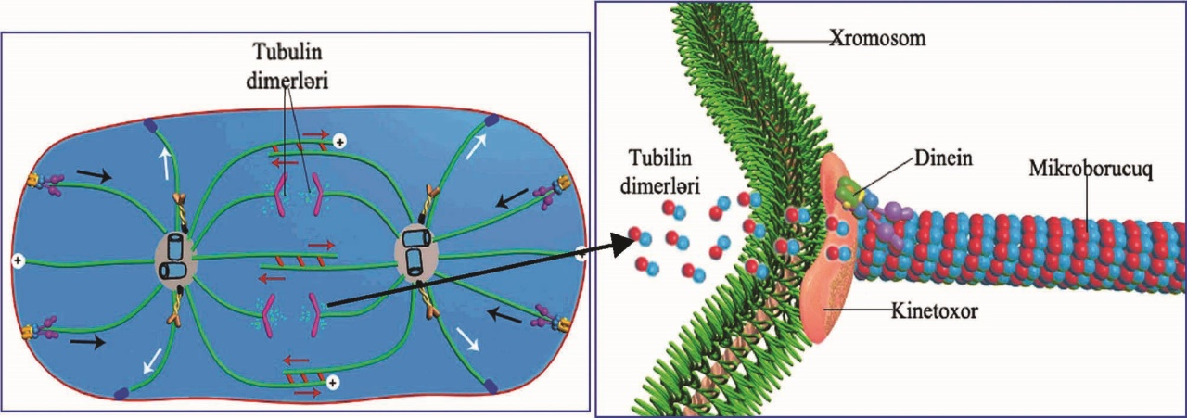
Figure 2.14.

- Movement of chromatids toward the pole in anaphase occurs of shortening of the microtubules via depolymerization at the kinetochore end.
- This, is coupled with the dynein associated with the kinetochore (Fig. 2.14.).

Telophase:
- Telophase is characterized by cytokinesis, reconstruction of the nucleus and nuclear envelope, disappearance of the mitotic spindle, and unwinding of the chromosomes into chromatin.
- The nucleoli reappear, and the cytoplasm divides to form two daughter cells.

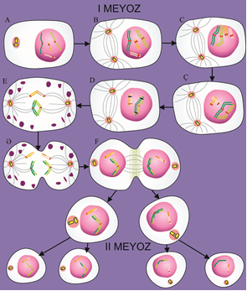
Figure 2.15.

Meiosis

- Meiosis involves two sequential nuclear divisions followed by cell divisions that produce gametes containing half the number of chromosomes and half the DNA found in somatic cells.
- The zygote and all the somatic cells derived from it are diploid (2n) in chromosome number.
- The gametes, having only one member of each chromosome pair, are described as haploid (1n).
- Meiosis is a specialized type of cell division that produces the germ cells – the ova and the spermatozoa.

Meiosis is divided into two separate events:
Meiosis I, or reductional division. Homologous pairs line up, members of each pair separate and go to opposite poles, and the cell divides; thus, each daughter cell receives half the number of chromosomes.
Meiosis II, or equatorial division. The two chromatids of each chromosome are separated, as in mitosis, followed by migration of the chromatids to opposite poles and the formation of two daughter cells.
Meiosis I:

Prophase I:
- Leptotene is characterized by the condensation of chromatin and by the appearance of chromosomes.
- Zygotene. Synapsis, the close accommodation of homologous chromosomes, begins. This process involves the formation of a synaptonemal complex, a tripartite structure that binds the chromosomes together.
- Pachytene. Crossingover and gene conversion occur and involves transposition of DNA strands between two different chromosomes.
- Diplotene. The synaptonemal complex dissolves, and the chromosomes condense further. Homologous chromosomes begin to separate from each other and connected by chiasma.
- Diakinesis. The homologous chromosomes condense and shorten to reach their maximum thickness, the nucleolus disappears, and the nuclear envelope disintegrates.
Metaphase I is characterized by homologous pairs of chromosomes, each composed of two chromatids. Lining up on the equatorial plate of the meiotic spindle.
Anaphase I. Homologous chromosomes migrate away from each other, going to opposite poles.
Telophase I. The migrating chromosomes, each consisting of two chromatids, reach opposite poles
Meiosis II (equatorial division) occurs without DNA synthesis and proceeds rapidly through four phases and cytokinesis to form four daughter cells each with the haploid chromosome number (Fig. 2.15.).

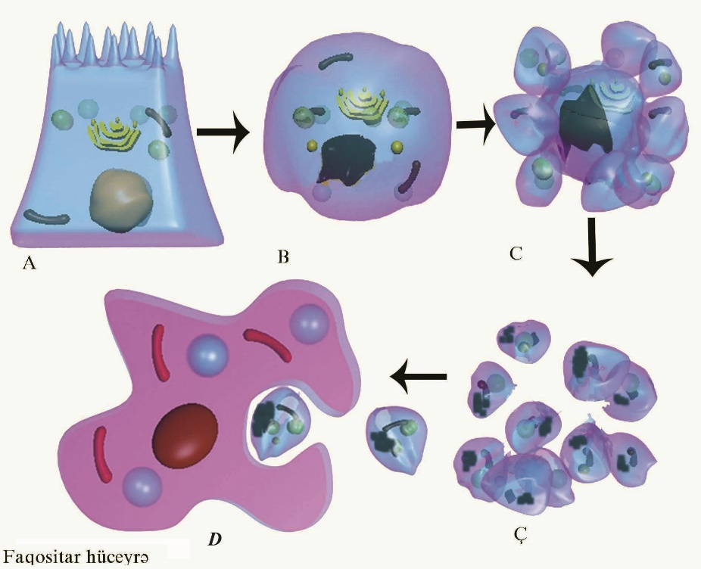
Figure 2.16.

Cells die as a result of various factors, including (1) acute injury, (2) accidents, (3) lack of a vascular supply, (4) destruction by pathogens or the immune system, and (5) genetic programming. During embryogenesis, many cells, such as those that would give rise to a tail in the human embryo, are driven into the genetically determined process of dying. This process continues on throughout adult life to establish a balance between cell proliferation and cell death. For example, in the adult human billions of cells die each hour within the bone marrow and digestive tract to balance cell proliferation in these tissues. Cell death by this means is called programmed cell death (apoptosis). In contrast to apoptosis, during necrosis the cell dies because of attack or injury that causes the cell to rupture, thereby exposing its contents to neighboring cells and thus initiating an inflammatory response. Because apoptosis has formidable consequences for the cell involved as well as for the organism, it must be carefully regulated, controlled, and monitored. The process of apoptosis is regulated by a number of highly conserved genes that code for a family of enzymes known as caspases, which degrade regulatory and structural proteins in the nucleus and in the cytoplasm. Activation of caspases is induced when certain cytokines, such as tumor necrosis factor (TNF), released by signaling cells, binds to the TNF receptor of the target cell. These TNF receptors are transmembrane proteins whose cytoplasmic aspect binds to adapter molecules to which caspases are bound. Once TNF binds to the extracellular moiety of its receptor, the signal is transduced and caspase becomes activated. The activated caspase is released and, in turn, triggers a cascade of caspases that results in the degradation of chromosomes, nuclear lamins, and cytoskeletal proteins. Finally, the entire cell becomes fragmented. The cell fragments are then phagocytosed by macrophages. However, these macrophages do not release cytokines that would initiate an inflammatory response (Fig. 2.16.).

- Morphologically, apoptotic cells shrink and the nucleus condenses. The organelles and nucleus break up, and then the cell breaks into fragments called apoptotic bodies - each surrounded by a plasma membrane.
- These express ligands (phosphatidylserine) on their surface membranes, promoting their uptake by phagocytes and neighboring normal cells.

